Cotswold Sailing Club
Sailing Instructions (Reviewed 2023) -
Open Meetings and Events
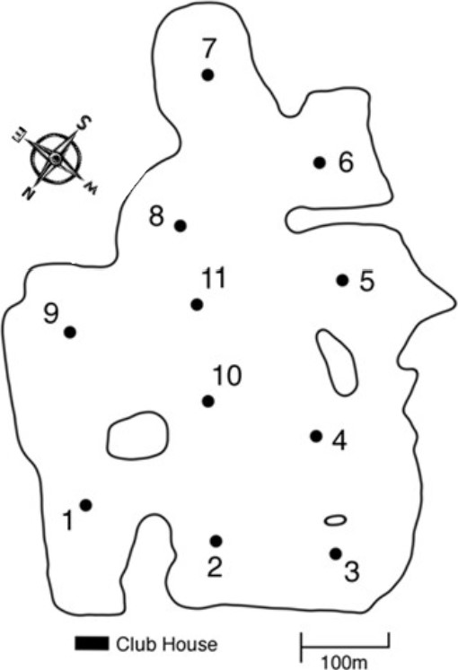

1. Rules
Races will be governed by the 'Rules' as defined in the Racing Rules of Sailing (RRS) 2021 2024. The UK national body for dinghy, yacht and all forms of sail racing is The Royal Yachting Association (RYA): http://www.rya.org.uk
COTSWOLD Sailing Club implements the RYA Racing Charter and helms are required to undertake to sail in compliance with the Charter, details of which can be found at the front of the RYA Rule Book (Racing Rules of sailing 2021-2024).
If there is conflict between the Notice of Race and the Sailing Instructions, then these Sailing Instructions shall prevail.
2. Notices to Competitors
Notices to competitors will be posted on the official notice board in the clubhouse.

3. Changes to Sailing Instructions (SIS)
Any change to the sailing instructions will be posted at least 30 minutes before the warning signal on the official notice board on the day it will take effect, except that any change to the schedule of races shall be posted by 2000hrs on the day before it will take effect

4. Signals Made Ashore
4.1 Signals made ashore will be displayed at the clubhouse.
4.2 When flag AP is displayed ashore '1 minute', in 'Race Signals' is replaced with 'not less than 30 minutes. This changes the meaning of AP in RRS Race Signals.
5. Schedule of Races
The schedule of races is defined in the Notice of Race.

6. Class Flags
Class flags are defined in the Notice of Race.

7. The course
7.1 The number of rounds to be sailed will be displayed on the course board, either on the committee boat or on the course board at the club house
7.2 The course displayed will be shown with numbers indicating the marks in the order that they should be passed and with a green or red background to indicate with side the mark should be left. The course displayed on the course board at the club house will be diagrammatic.
7.3 When an alteration to the course is made, two sound signals will be made and International Code Flag Numeral Pennant Two flown.
7.4 All boats must pass through the start/finish line at the end of each lap (see para. 11)
7.5 All boats which are racing must 'start, sail the course and then finish' in accordance with Rule 28. The Race Officer will disqualify a boat without hearing for not sailing the course and that boat will be scored NSC (Did Not Sail Course). Boats may request redress if they disagree with the decision of the Race Officer.

8. Marks
Marks 1 to 11 are red numbered spherical buoys. All course marks are rounding marks. A black spherical buoy may be used in addition to the standard red buoys as a windward mark.
Please note that the map of Lake 9 shows buoys in their 'normal' positions, but they can be moved at the discretion of the Race Officer.

9. The start
9.1 The starting line will be between the red/orange and white pole on the committee boat and an outer limit buoy.
9.2 Boats whose warning signal has not been made shall avoid the starting area during the starting sequence for other races.
9.3 A boat starting later than 4 minutes after her starting signal will be scored Did Not Start (DNS) without a hearing. This changes Rule A4.
9.4 When at a boat's starting signal any part of her hull, crew or equipment is on the course side of the starting line or she must comply with rule 30.1, the race committee shall promptly display flag X with one sound. The flag shall be displayed until all such boats have sailed completely to the pre-start side of the of the starting line or one of its extensions and have complied with rule 30.1 if it applies, but no later than four minutes after the starting signal or one minute before any later starting signal, whichever is earlier. If rule 30.3 or 30.4 applies this rule does not.
9.5 When at the starting signal the race committee is unable to identify boats that are on the course side of the starting line or to which rule 30 applies, or there has been an error in the starting procedure, the race committee may signal a general recall (display the First Substitute with two sounds). The warning signal for a new start for the recalled class shall be made one minute after the First Substitute is removed (one sound), and the starts for any succeeding classes shall follow the new start.
9.6 Inner and outer limit marks may be laid as part of the start. These marks are part of the course and competitors must pass through the start line at the end of each lap. The start line is bounded by these marks and boats must pass between them at the start. Boats may not pass between the inner distance mark and the committee boat during the starting sequence or during a race. A boat so passing will be scored DSQ (Disqualification) without a hearing. This changes Rule A5.
9.7 The start sequence for all races will be 5,4,1,GO (as per RRS Rule 26) as indicated in the following table:
Minutes before starting signal | Visual Signal | Sound Signal | Means
5 | Class flag displayed | One | Warning signal
4 | P, I, U, or Black flag displayed | One | Preparatory signal
1 | Preparatory flag removed | One long | One minute
0 | Class flag removed | One | Starting signal

10. Change of Course
The Race Officer may at his discretion move a mark after the start of the race without a signal. This changes Rule 33.

11. The Finish
11.1 For all races the finishing line will be a line between the red/orange and white pole on the committee boat and an outer limit buoy.
11.2 Inner and outer limit marks may be laid as part of the finish line. The finish line is bounded by these marks and boats must pass between them to finish. Boats may not pass between the inner distance mark and the committee boat after finishing. A boat so passing will be scored DSQ (Disqualification) without a hearing. This changes Rule A5.

12. Time Limit and Target Times
12.1 The 'target times' (i.e., race duration) are defined in the Notice of Race.
12.3 The time limit for the first boat shall be as defined in the Notice of Race.
12.4 At the Race Officer's discretion, boats which are a long distance behind, and would otherwise be timed out, may be finished after completing fewer laps than the leading boat. Their time will be adjusted through the use of the average lap times. These boats will be individually informed that they have been finished by the Race Committee or safety boat. This changes Rule 28.
13. Scoring
13.1 Appendix A5.3 of the RRS rules will apply to scoring.

13.2 The low point scoring system of Appendix A will apply on the day of racing, except where an event runs over more than 2 days, then A8.2 will be changed to rank competitors in order of best discard scores.

13.3 Discards for the event are as per the RRS

13.4 In order to qualify for a prize, a competitor must have the minimum number of races to count as shown in the programme.

14. Protests
14.1 Protests forms are available at the club house office. Protests and requests for redress or reopening shall be delivered to the Race Officer.
14.2 For all classes the protest time limit is 30 minutes after the Race Officer returns to shore, after the last boat has finished the last race of the day or the race committee signals no more racing today, whichever is later.
14.3 The Advisory Hearing and RYA Arbitration procedures of the RYA Rules Disputes Procedures will be available. Decisions from RYA Arbitration can be referred to a protest committee but cannot be reopened or appealed.
14.4 Except for protests associated with Rule 2 and Rule 69, independent observers are permitted to sit in on arbitration and advisory/ protest hearings for educational purposes. All parties and the protest committee must agree to their presence beforehand. Such observers are not allowed to speak during the course of the hearing and must not influence the proceedings in any way.

15. Electronic Equipment
15.1 Except in an emergency a boat that is racing shall not make voice or data transmissions and shall not receive voice or data transmissions that is not available to all boats.
15.2 Only a camera and compass (digital or analogue) may be used by sailors.

16. Risk Statement
16.1 Rule 4 of the Racing Rules of Sailing states: "The responsibility for a boat's decision to participate in a race or to continue to race is hers alone" Sailing by its nature is an unpredictable sport and therefore inherently involves an element of risk. By taking part in the event, each competitor agrees and acknowledges that:
- They are aware of the inherent element of risk involved in the sport and accept responsibility for the exposure of themselves, their crew and their boat to such inherent risk whilst taking part in the event.
- They are responsible for the safety of themselves, their crew, their boat and their other property whether afloat or ashore.
- They accept responsibility for any injury, damage or loss to the extent caused by their own actions or omissions.
- Their boat is in good order, equipped to sail in the event and they are fit to participate. (e) The provision of a race management team, patrol boats and other officials and volunteers by the event organiser does not relieve them of their own responsibilities.
- The provision of patrol boat cover is limited to such assistance, particularly in extreme weather conditions as can be practically provided in the circumstances.
- It is their responsibility to familiarise themselves with any risks specific to this venue or this event drawn to their attention in any rules or information produced for the venue or event and to attend any safety briefing held for the event.

17. Safety Regulations
17.1 Competitors shall wear a personal flotation device (pfd), at all times, whilst afloat except when changing or adjusting clothing or personal equipment. This changes RRS 40. Wetsuits or dry suits are not considered to be adequate as a pfd.
17.2 Wetsuits or dry suits must be worn by all competitors between 1st November and 30th April inclusive.
17.3 a) It is a condition of entry that a Competitor shall comply with the instructions of Safety Boat crews, whose priority is to help competitors in distress or danger before retrieving boats. b) Any action by these crews solely intended to ensure the safety of a competitor, such as recovering crew or separated components of the boat, provided this does not materially advantage the boat concerned, is not "outside help" as defined in RRS 41 and is not subject to protest from another competitor. The competitor may continue to race. This amends RRS 41.

18. Insurance
Each participating boat shall be insured with a valid Third-Party Liability Insurance with a Minimum Cover of £3 million.
END OF SAILING INSTRUCTIONS.

