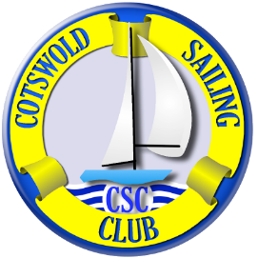

COTSWOLD SAILING CLUB

Organising Authority: Cotswold Sailing Club in conjunction with Wanderer Class Owners’ Association (WCOA)
WCOA Inland Championship
Saturday 1st & Sunday 2nd July 2023

NOTICE OF RACE (NOR)
- RULES
  - The regatta will be governed by current rules as defined in The Racing Rules of Sailing 2021 to 2024.
  - RYA prescriptions to the Racing Rules of Sailing as well as Cotswold Sailing Club rules and byelaws will apply.
  - The Sailing Instructions will apply.
  - RRS 40.1 applies at all times when competitors are afloat.

- ADVERTISING
  - Boats are permitted to display advertising under ISAF Regulation 20

- ELIGIBILITY AND ENTRY
  - The regatta is open to all boats of the Wanderer class whose helm or crew is a fully paid-up member of the WCOA at the time of entry.
3.2 Entries should be made online in advance on the class association website; www.wanderer.org.uk by 8am on Thursday 29th June.

- DECISION TO RACE
  - The responsibility for a boat's decision to participate in a race or to continue racing is theirs alone.
- FEES
  - Entry fee is £17 (covered by the WCOA). No catering will be provided, except as outlined in section 20 ‘further information’. Competitors must bring their own lunch and refreshments.

- SERIES
  - The event will consist of five races – four races will constitute a series. If, at the discretion of the RO, one or more races are cancelled due to bad weather or poor/ unsuitable wind conditions the following will apply:
Four races held: four races will constitute a series.
Three races held: three races will constitute a series.
Two races held: two races will constitute a series.
One race held: one race will constitute a series.

- SCHEDULE
7.1 Test Sail: Friday 30th June competitors may enjoy a test sail/ cruise at any time
7.4 Briefing: Saturday 1st July 11.30am (in the clubhouse)
7.5 Post race: After racing on Saturday 1st July tea and cake will be available in the
clubhouse
7.5 BBQ: On Saturday 1st July at 7pm competitors are invited to a BBQ (at £15 a head)
featuring local meat, salad, baked potatoes followed by apple crumble and ice-cream. Local beer will also be available on a donation basis. Please register for and pay for your BBQ in advance on the class association website; www.wanderer.org.uk by 8am on Thursday 29th June.
7.6 Prize-giving: Presentation of prizes will be at approximately 2.30/3pm on Sunday 2nd July

7.7 Times of racing:

Saturday 14th Sept
Race 1 not before 12pm
Race 2 at the discretion of the RO.
Race 3 at the discretion of the RO.

Sunday 15th Sept
Race 4 not before 10am
Race 5 at the discretion of the RO.

After the regatta, boats are welcome to join CSC regular scheduled Sunday racing at 3pm.

7.8 The schedule may be amended at any time to comply with covid restrictions.

- MEASUREMENTS
  - All boats shall comply with their class rules. Measurement checks may be carried out at any time during the event. Only certified sails may be used in line with class rules.

- SAILING INSTRUCTIONS
  - Sailing instructions are available on the Cotswold Sailing Club website ‘Open Events’ page – www.cotswoldsailingclub.org)

- VENUE
10.1 Directions to Cotswold Sailing Club, Lake 9, Cerney Wick Lane, Cotwold Water Park GL7 5QJ can be found on the club web site - https://www.cotswoldsailingclub.org/find-us The entrance to the club is a gate half way along Cerney Wick Lane, between the junction with the Spine Rd East and Cerney Wick village. Please DO NOT use the club post code for your sat nav. This will take you to Cerney Wick village where it is hard to turn around, especially if you are towing a boat. Instead, head towards the Cotswold Outdoor/Gateway Café on Spine Rd East (GL7 5TL) and depending on the direction you are arriving from, turn into Cerney Wick Lane towards Cerney Wick (signposted) at the crossroads. Be careful though – do not be confused with South Cerney Sailing club, which is on the same road in the opposite direction, towards South Cerney (also signposted!)

(Please note local road closures may in operation – please leave extra time for your journey.)

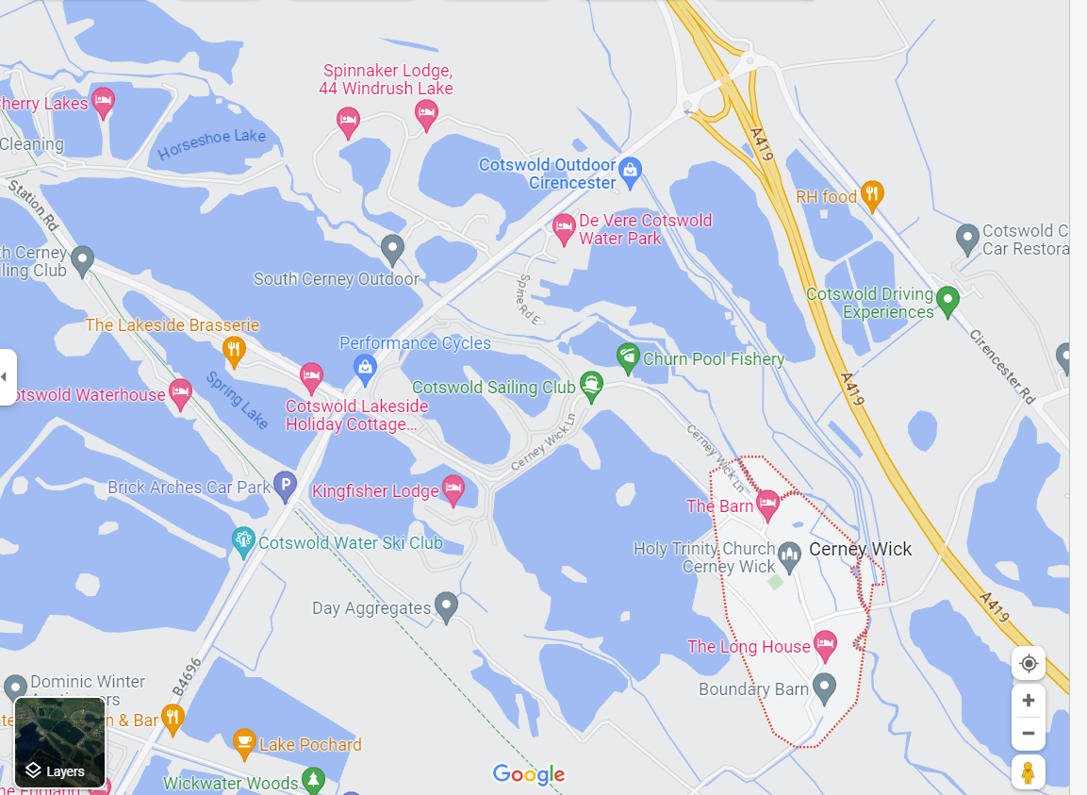 Entrance to CSC (Cerney Wick Lane)

11. THE COURSES
11.1 The courses will be set out on the day by the race officials and will be displayed on the race board and/or on the committee boat.

12. PENALTY SYSTEM
12.1 The penalties are as detailed in rule 44. The Scoring Penalty rule 44.3 will not apply.
12.2 Decisions of the protest committee will be final as provided in rule 70.4.

- SCORING
13.1. The Low Point System of Appendix A will apply.
13.2. When 5 races have been completed, a boat’s series score will be the total of her 4 best race scores When less than 4 races are scored there will be no discards.
13.3 RRS A5.3 will apply.
13.4 RRS 90.3(e) will apply.

- RADIO COMMUNICATION
14.1 Except in emergency a boat shall neither make radio transmissions while racing nor receive .radio communications not available to all boats. This restriction also applies to mobile telephones.

15. DISCLAIMER OF LIABILITY
15.1 Competitors participate in the regatta entirely at their own risk. See rule 4, Decision to Race. The organising authority will not accept any liability for material damage or personal injury or death sustained in conjunction with or prior to, during, or after the regatta.

- INSURANCE
16.1 Each participating boat shall be insured with valid third-party liability insurance with a minimum cover of £3Million per event or the equivalent.

17. PRIZES
17.1 Prizes will be awarded for 1st, 2^{nd,} and 3rd place. First place helm will receive the WCOA Inland Championship trophy.
17. 2 Other prizes may be awarded at the discretion of Cotswold Sailing Club

18. RIGHTS TO USE NAMES AND LIKENESSES
18.1 Competitors automatically grant to the organising authority without payment the right in perpetuity to make, use, and show any motion pictures, still pictures and live, taped, or filmed television of or relating to the event.
18.2 Cotswold Sailing Club has a GDPR policy compliant with the 2018 regulations.

19. DISCLAIMER OF LIABILITY
19.1 Cotswold Sailing Club will not accept any liability for material damage, personal injury, or death sustained in conjunction with or prior to, during, or after the regatta.
19.2 Competitors participate in the regatta entirely at their own risk; see rule 4, Decision to Race.

20. FURTHER INFORMATION

20.1 Visiting boats must be washed down on arrival using the hosepipe situated in the car park by the main gate.
20.2 Upon registration competitor’s will be given the four-digit gate number to the club’s main gate, clubhouse and intermediate gates from Thursday 29th June to Monday 3rd July. If there are any difficulties accessing the site, please email leonie.milliner@outlook.com Competitors are asked to keep the gate lock/ clubhouse lock number confidential and under no circumstances to share the gate number with anyone outside their party. Please close and lock all gates/doors after use. Please do not ‘hold open’ main gate, side gates or clubhouse back door to anyone.
20.3 Competitors’ tents, caravans and campervans are welcome to stay overnight in the camping field/ lakeside from 5pm on Thursday 29th May to Monday 3rd May at £5 per adult per night, payable in cash to the galley on Sunday 2nd July. Please note there is no electric hook up. Turn right on entering the main gate and follow the haul road around the edge of the lake to the camping field. Visiting boats may be left in the main car park, to the left and in front of the main gate. A bike (or folding bike) is recommended!
20.3 Limited catering will be provided. Competitors must bring their own lunch and refreshments. Tap water is available.

It is the club’s policy that you must not enter the club if you have tested positive for covid, or have covid-like symptoms. If you test positive for covid whilst at the club, we ask you to self-isolate as soon as possible.

